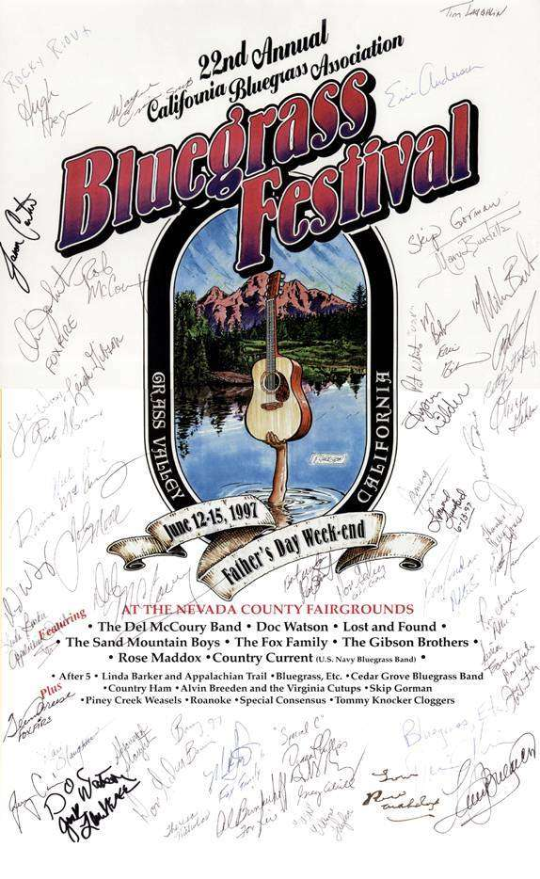

The Del McCoury Band
June 13 and 14, 1997
Grass Valley, California

The Del McCoury Band, Grass Valley, California

June 13, 1997June 14, 1997

(introduction)1.(introduction)
Don't You Call My Name2.Train 45 to California
High on a Mountain3.Rain Please Go Away
Chicken Under the Washtub4.Bluest Man In Town
Beauty of My Dreams5.A Good Man Like Me
Another Place, Another Time6.(instrumental)
The Cold Hard Facts7.Snake In the House
Shuckin' the Corn8.I Can't Get You Off My Mind
Don't Our Love Look Natural9.Back Up & Push
Lights On The Hill10.Daisy Mae
Grass Valley11.Blackjack County Chains
Little Darlin' Pal o' Mine12.Baltimore Johnny
Thanks A Lot13.Get Down On Your Knees and Pray
Highway of Pain14.True Life Blues
I Believe15.Roanoke
Whitehouse Blues(encores:)
(applause, encores:)16.That Smokin' Gun
Queen Anne's Lace17.Cheek to Cheek With the Blues
Big ock in the Road

NOT FOR SALE, BROADCAST OR COMMERCIAL REPRODUCTION
The Del McCoury Band, June 13 & 14, 1997, Grass Valley, CA
The Del McCoury Band, June 13 & 14, 1997, Grass Valley, CA

